International Journal of Multidisciplinary Advanced Research (IJMAR)
(A Multidisciplinary Journal of Humanities, Law, Management and Commerce)
1 | Deputy Editor-in-Chief:  Dr. Ram Pratap Yadav  Asst. Professor& Programme Coordinator, FoHSS  rampratap.hum@srmu.ac.in | 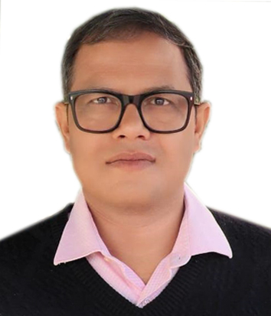
2 | Associate Editor:  Dr. Anil Kumar  Associate Professor, FoHSS  anilkumar.hum@srmu.ac.in | 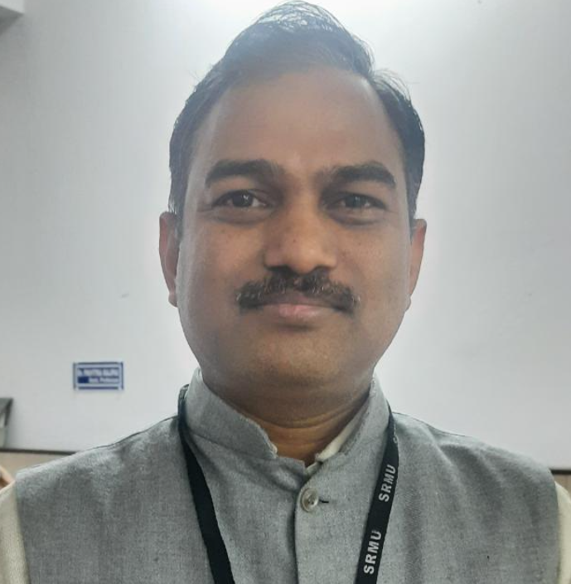
3 | Associate Editor:  Dr. Shweta Shukla  Associate Professor, FoHSS  shwetashukla.hum@srmu.ac.in | 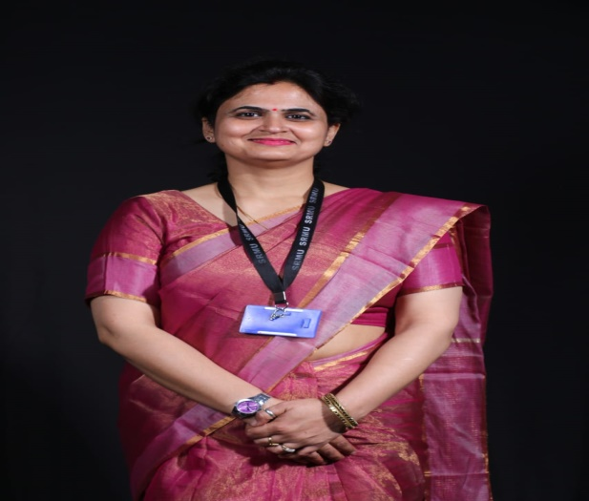
4 | Associate Editor:  Dr. Shilpa Shukla  Shilpa Shukla  Associate Professor, FoHSS  indian.sshilpa@gmail.com | 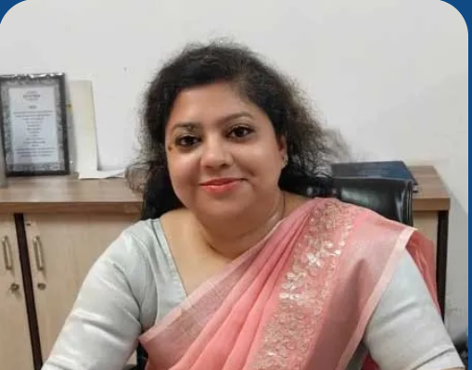
5 | Associate Editor:  Dr. Prakash Chandra Mishra  Associate Professor, ILS  prakash.law@srmu.ac.in | 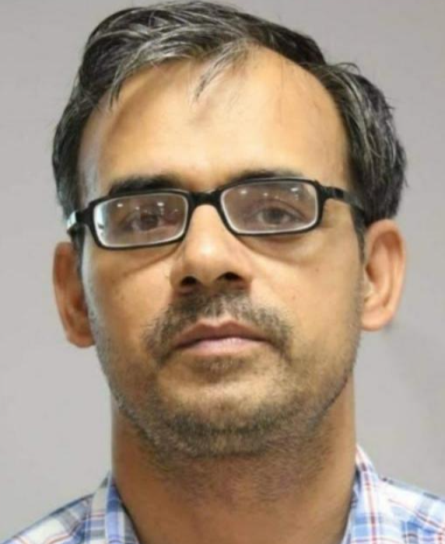
6 | Associate Editor:  Dr. Shashank Shekhar Singh  Associate Professor, ILS  shashanshekher.ils@srmu.ac.in | 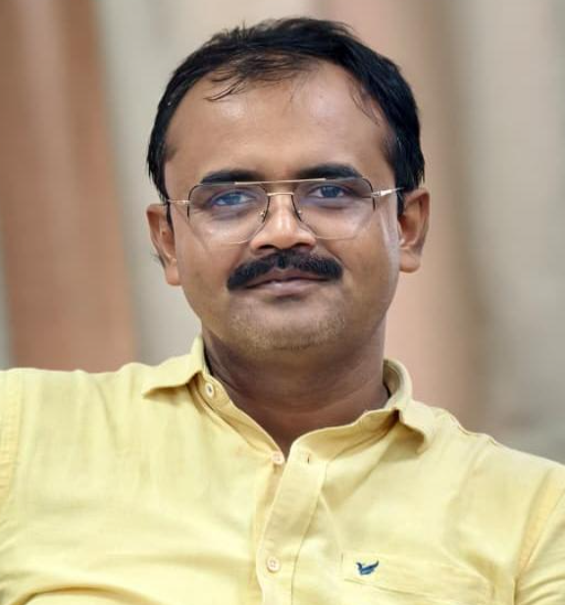
7 | Associate Editor:  Dr. Vibhav Sharma  Assistant Professor, Management  vaibhavsharma.ecocommerce@srmu.ac.in | 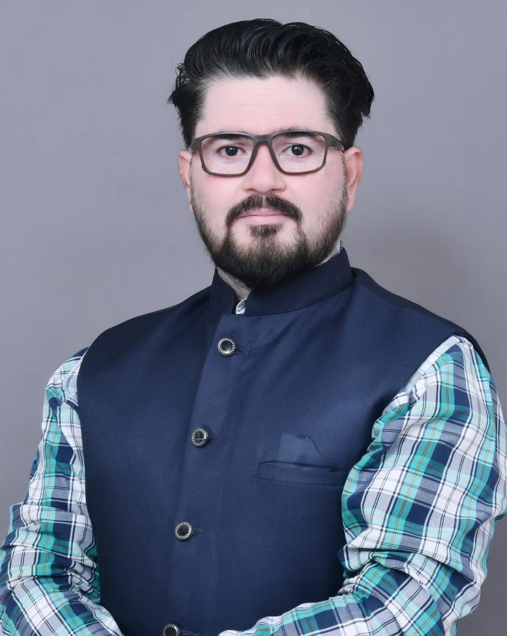
8 | Associate Editor:  Dr. Syed Asif Mehdi  Assistant Professor, Management  syedasifmehdi.management@srmu.ac.in | 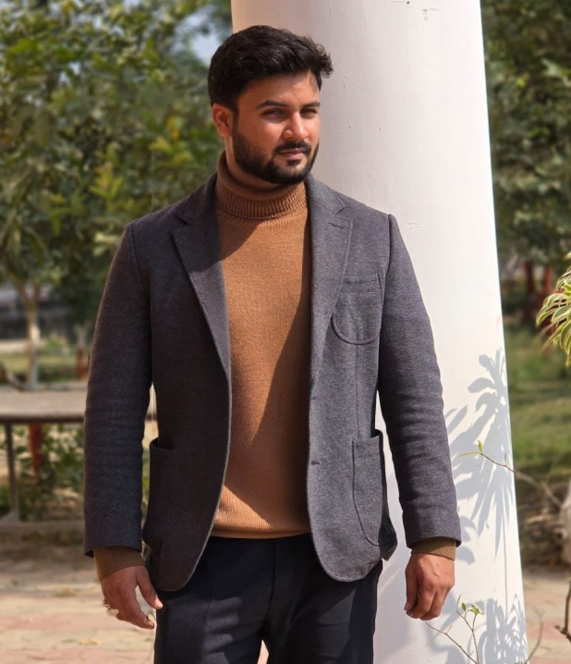
9 | Associate Editor:  Dr. Seema Tripathi  Assistant Professor, Management  seematripathi.imce@srmu.ac.in | 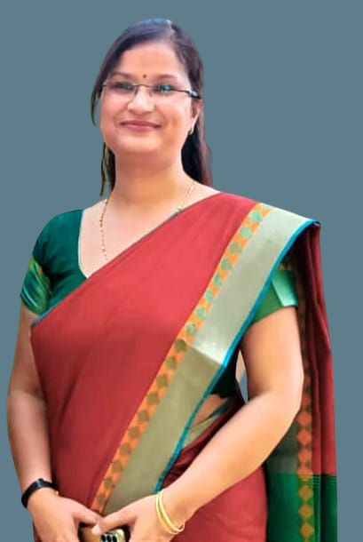
10 | Associate Editor: Dr. Shikha Srivastava  Professor, Pharmacy  shikhasri.pharma@srmu.ac.in | 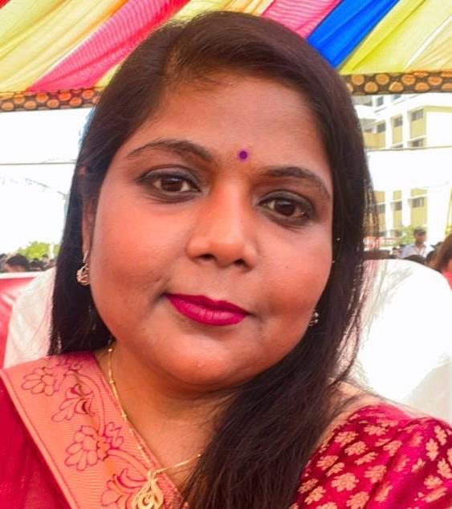
11 | Associate Editor: Dr. Ajeet Singh  Assistant Professor, Pharmacy  ajeetsingh.pharmacy@srmu.ac.in | 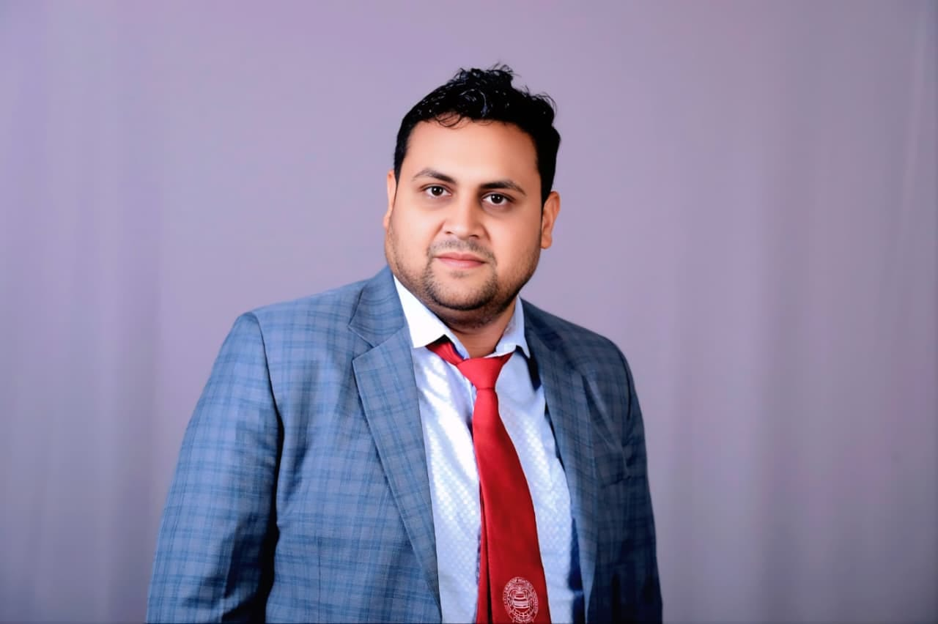
12 | Dr. Dhwani Singh  Asst. Professor  Institute of Media Studies  dhwanisingh.ims@srmu.ac.in | 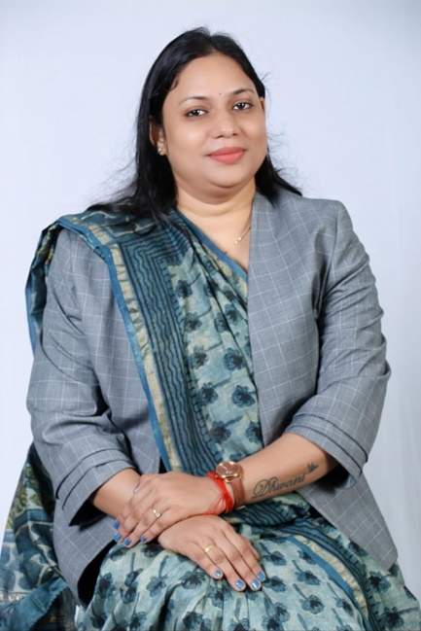
13 | Dr. Amit kumar singh  Assistant Professor  Institute of Media Studies  amitkumarsingh.Ims@srmu.ac.in | 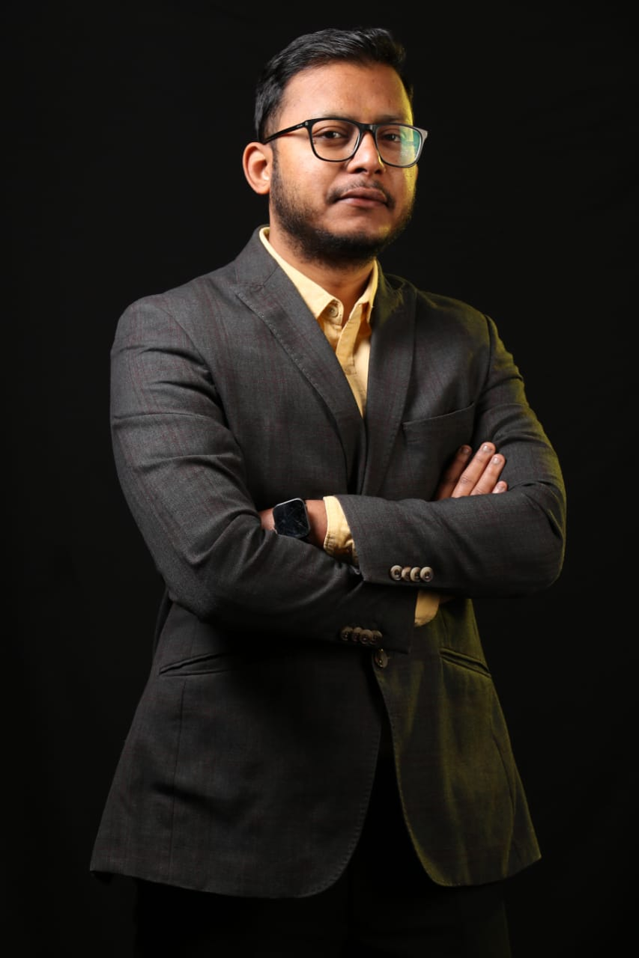
14 | Advisory Committee:  Prof. B.M. Dixit  Director, INSH  director.insh@srmu.ac.in | 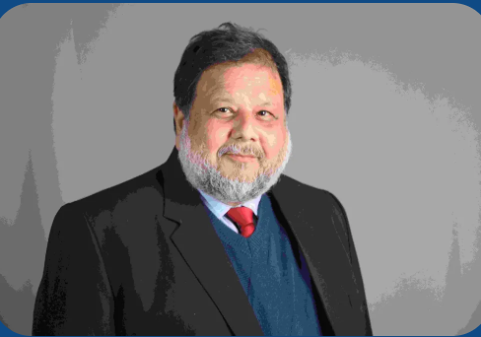
15 | Advisory Committee:  Prof. Narendra Bahadur Singh  Director, Law  director.Law@srmu.ac.in | 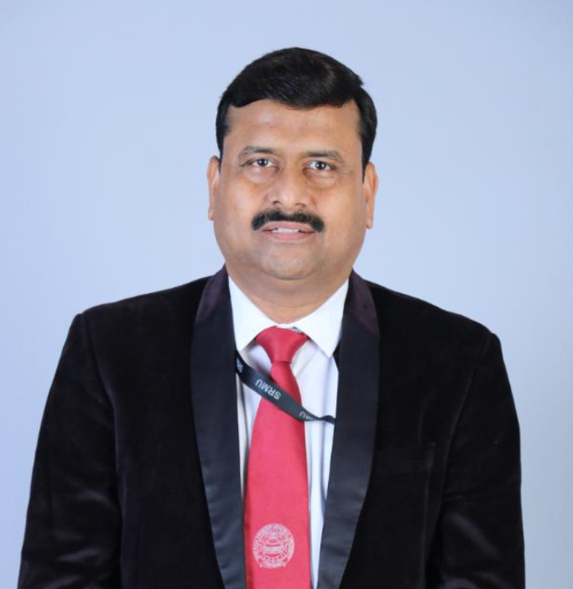
14 | Advisory Committee:  Prof. Veena Singh  Head, IMCE  veenasingh.imce@srmu.ac.in | 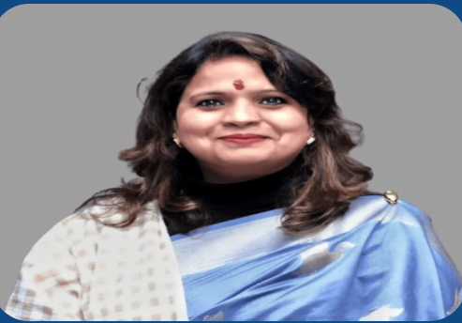
15 | Advisory Committee:  Prof. Madhu Dixit  Head, Commerce  madhu.mgmt@srmu.ac.in | 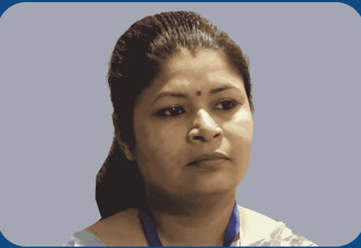
16 | Advisory Committee:  Prof. Manju Pandey  Director, Pharmacy  director.pharma@srmu.ac.in | 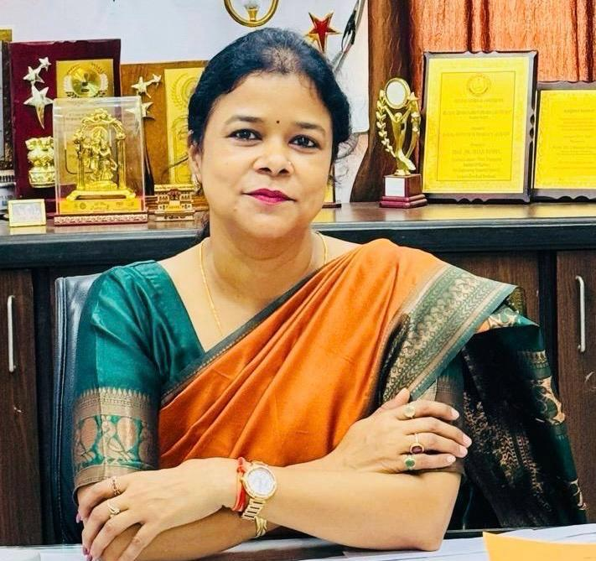
17 | Dr. Pradeep Kumar  Director, IMS  Dr. Pradeep Kumar  Pradeepkumar.ims@srmu.ac.in | 